环境准备: JDK 8+ eclipseIDE 2019+(最新版) tomcat 9.0+

数据库搭建在我们的远程服务器上因此不需要安装，但要保持联网状态

1. JDK version 8 or above

<https://www.oracle.com/java/technologies/javase-jdk8-downloads.html>

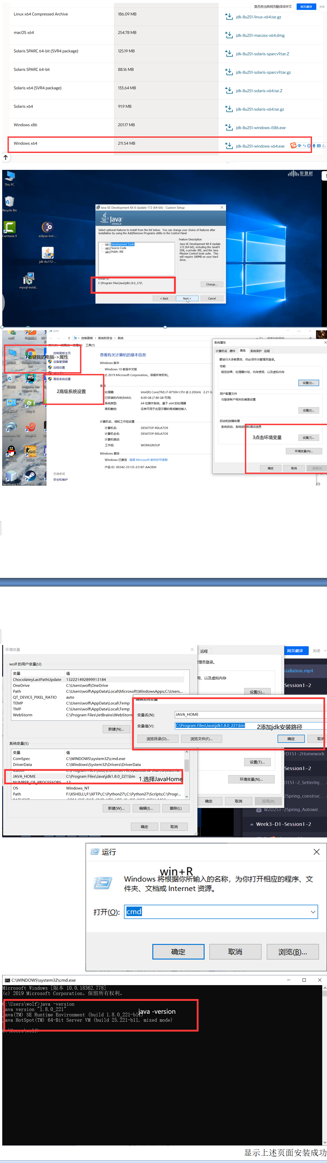

显示上述页面安装成功

2.Application  Server

<https://tomcat.apache.org/download-90.cgi>

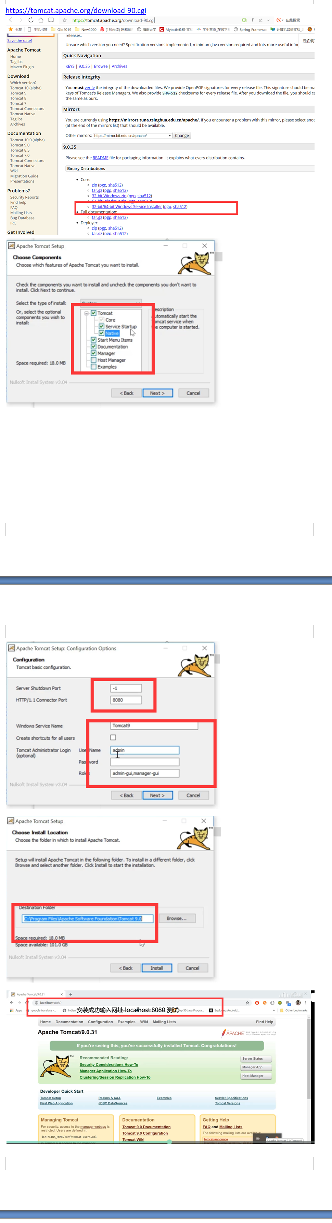

显示上述页面安装成功

3.IDE Eclipse

<https://www.baidu.com/link?url=SpOOPigq-t6ehXla1lxU2makAOxk9de4PmYs46UjWZTF1FfdKzb_fH1iOj9MYJ4r&wd=&eqid=ca759c81000548b3000000065ec26928&tn=78040160_5_pg&ch=9>

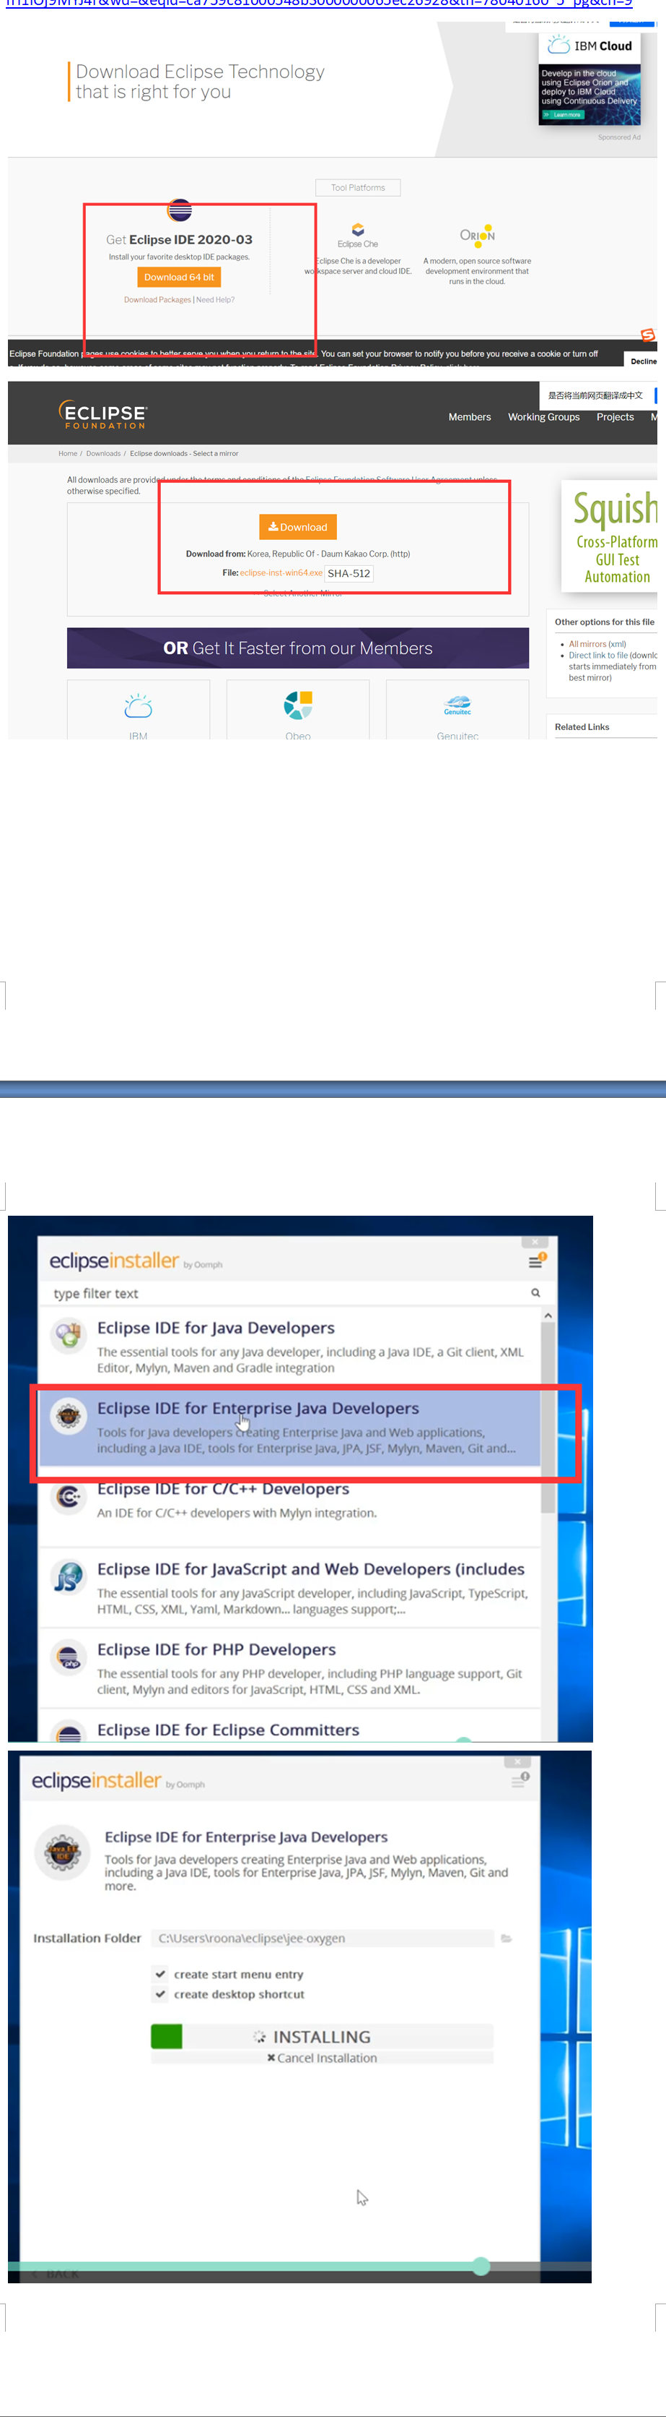

4.Connect tomcat server to eclipse

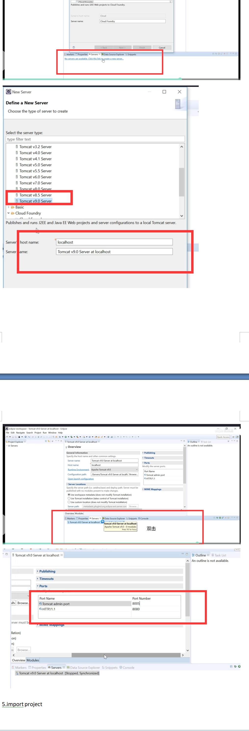

5.import project

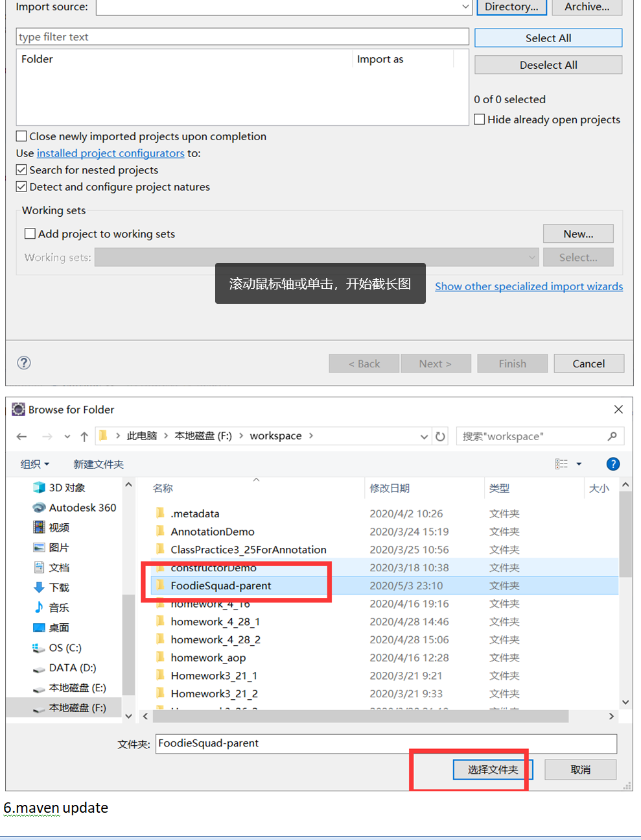

6.maven update

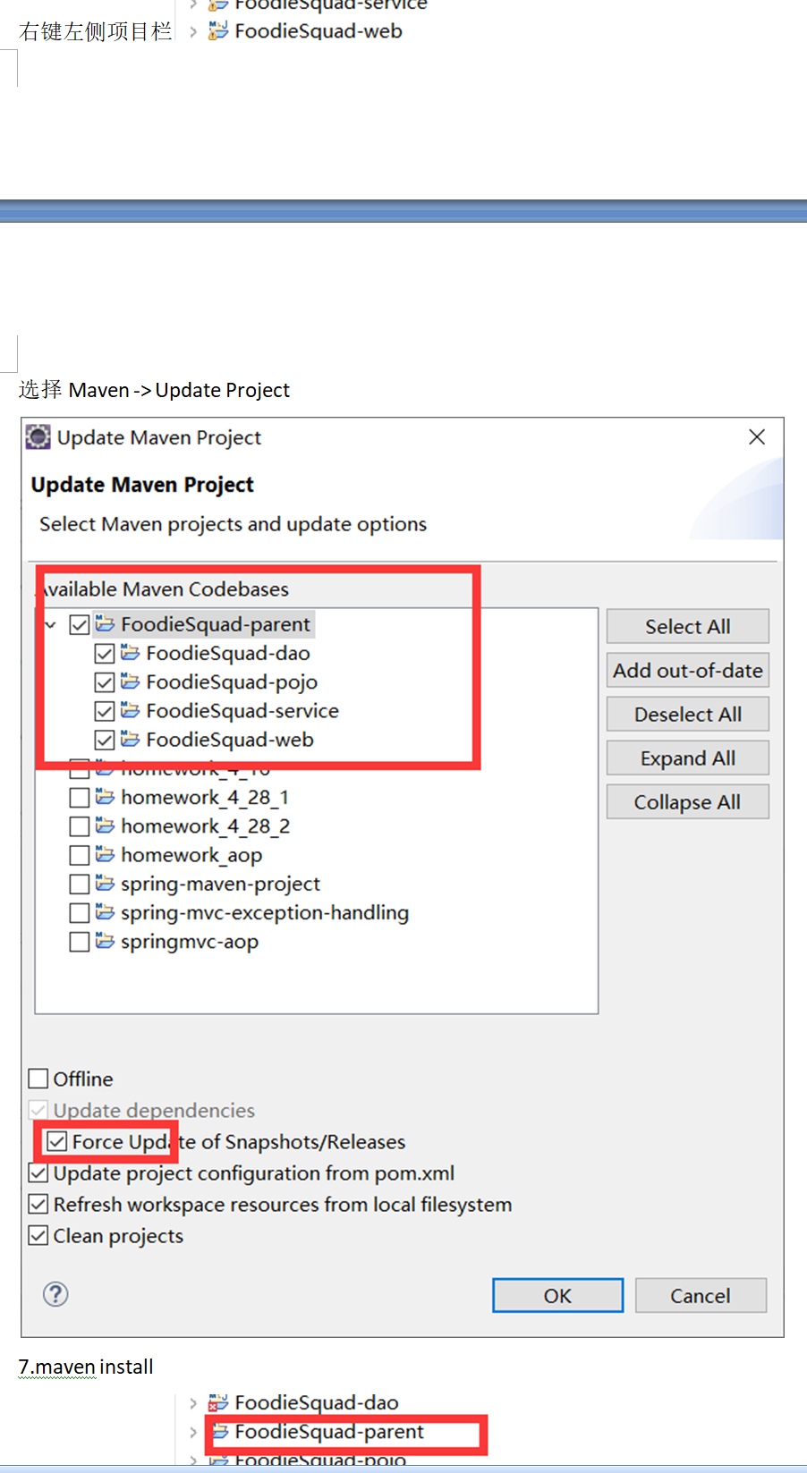

右键左侧项目栏

选择Maven -> Update Project

7.maven install

右键左侧项目栏

选择Run As -> Maven Install

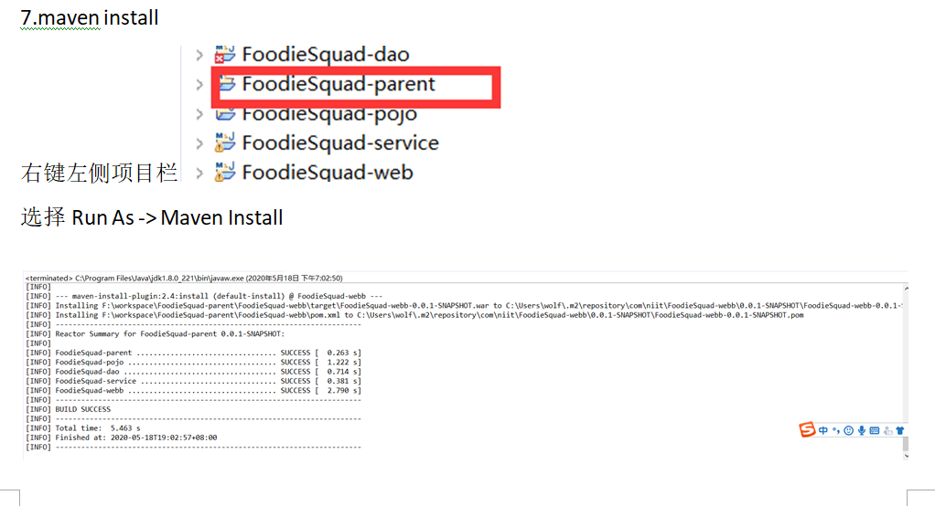

8.Run On server

右键左侧项目栏

选择Run As -> Run On server

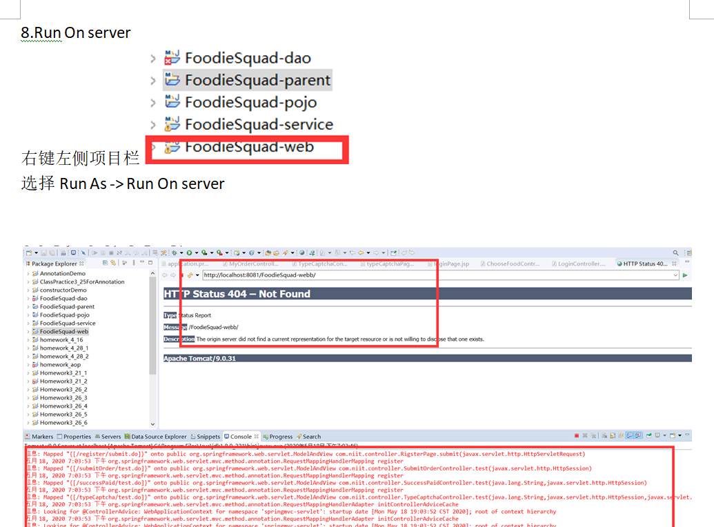

下方控制台没有报错安装成功

9./login/test.do

在域名后接网址/login/test.do开始运行

